Online Supplementary Information

Selection of major companies in the three regions
The largest companies of the most important economic sectors of the three regions for the seven benchmark years have been selected based on one or several of four criteria: nominal share capital, turnover, number of employees, and market capitalization. For the banking and insurance sector, the criterion was total of assets and net prime income, respectively, as these indicators better capture a company’s size in these two financial services sectors. Depending on the benchmark year, we could rely on only one or on several of these indicators. For instance, for the year 1890, information on nominal share capital was the only indicator available, whereas for the years 1980, 2000 and 2020, we based our selection mainly on the number of employees, turnover, and market capitalization provided by specialized publications listed below. In between, different publications by the largest Swiss banks provided lists of the largest Swiss companies by economic sectors.
Determining the largest companies was more complicated in some business sectors than in others. On the one hand, this was due to the organization of particular sectors in certain benchmark years. For instance, in the banking sector in 1890, there was essentially a division of labor between different banks, each of which engaged in particular types of activities (Mazbouri 2020). This meant that we had to include a larger number of companies from the banking sector in order to appropriately capture the sector at the end of the 19th century. On the other hand, determining the largest companies was also complicated by missing information on companies’ activities. Particularly private banks – such as Pictet & Cie., Mirabaud, or Sarasin – and watch-making companies have been, and some of them still are, rather secretive about their business activity. Therefore, for these companies and sectors we had to rely on secondary literature, such as Donzé’s (2017) history of the Swiss watch-making industry or Mazbouri’s (2020) history of the private banking sector. Similarly, for the first benchmark years, secondary literature, such as monographic studies on, and annual reports of, individual companies, consulted in the archive, were also important to complete the list of the most important companies and of their directors (for more details on the sources and methodology, see https://wp.unil.ch/sinergia-elites/database/ and David et al. 2015: 440 ff.).
The main sources used for the different benchmark years were the following:
1890: Orell Füssli (1891, 2nd ed.). Handbuch der Aktiengesellschaften und Geldinstitute der Schweiz. Zurich.
1910: Credit Suisse (Ed.) (1911). Vade-mecum des Bourses de Zurich/Bâle/Genève/
Lausanne/Berne/Neuchâtel/St-Gall/Coire 1910-11. Zurich.
1937: Töndury, H. (Ed.) (1938). Schweizerisches Finanz-Jahrbuch 1938. Bern.
1957: Frehner E. (Ed.) (1960). Schweizerisches Finanz-Jahrbuch 1955/1960. Zurich.
1980: UBS (1980). Les principales entreprises suisses. Zurich.
2000: Handelszeitung und Finanzrundschau AG (2000). Handelszeitung Top 2000. Die grössten Industrie-, Handels- und Dienstleistungsunternehmen, Banken und Versicherungen der Schweiz.
2020: Schweizerische Handelszeitung (2020), Die grössten Industrie-, Handels- und Dienstleistungsunternehmen in der Schweiz.

In addition, the following monographs were used for particular sectors and companies:
Sectors:
Banking
Cassis, Y. (1991). L’histoire des banques suisses, aux XIXe et XXe siècles. Revue Suisse d'Histoire, 41, 512-520.
Mazbouri, M. (2020). La banque privée comme métaphore: «vieille banque» et «nouvelle banque» en Suisse 1800-1930. Revue suisse d’histoire, 70, 93-115 and 286-306.
Tanner, J. & Cassis, Y. (1993). Banken und Kredit in der Schweiz = Banques et crédit en Suisse : (1850-1930). Chronos.

Watch-making
Donzé, P. (2017). L’invention du luxe: Histoire de l’industrie horlogère à Genève de 1815 à nos jours. Neuchâtel: Editions Alphil.

Companies:
Banking and insurance
Bank Sarasin und Cie (1978). A. Sarasin & Cie Banquiers Basel/Zürich. Bank Sarasin.
Banque de Genève (1922). Historique de la Banque de Genève à l’occasion de son 75me exercice. Banque de Genève.
Basler Handelsbank (1912). Festschrift zum 50-jährigen Jubiläum 1862-1912. Basler Handelsbank.
Basler Kantonalbank (1975). 75 Jahre Sicherheit und Vertrauen Basler Kantonalbank, 1899-1974. Basler Kantonalbank.
Bauer, H. (1972). Société de Banque Suisse, 1872-1972. Société de Banque Suisse.
Bauer, H. (1988). 125 Jahre Basler Handelsbank 1863-1988. Basler Handelsbank Beteiligungs- und Finanzgesellschaft.
Bieri, E. (1990). Eine Familie und ihre Bank. Bank Julius Bär 1890-1990. Bank Julius Bär.
Escher, M. von et K. Lüönd (2013). Sicherheit als Prinzip 150 Jahre und eine Zukunft für die Basler. Bâloise-Holding AG.
Fehr, K. (2013). Vontobel, 1924-2012. Bank Vontobel.
Genevoise assurances (1928). La Genevoise compagnie d’assurances sur la vie : Genève.
Gfeller, C. & Honegger, A. (2005). Im Wechsel der Perspektiven 250 Jahre Bank Leu. Orell Füssli.
Hauser, P. (1969). 100 Jahre Zürcher Kantonalbank, 1870-1970 Denkschrift. Genossenschaftsdruckerei Zürich.
Hildenbrand, A. (2008). Swiss Life 150 Jahre : Das Magazin zum Jubiläum. Swiss Life.
Hiler, D. (1991). CEG Genève, Caisse d’épargne de la République et Canton de Genève, 1816-1991. CEG Genève.
Jöhr, A. (1956). Schweizerische Kreditanstalt 1856-1956 hundert Jahre im Dienste der schweizerischen Volkswirtschaft. Schweizerische Kreditanstalt.
Jung, J. (2000a). Die Winterthur: eine Versicherungsgeschichte. NZZ-Verlag.
Jung, J. (2000b). Von der Schweizerischen Kreditanstalt zur Credit Suisse Group : Eine Bankengeschichte. NZZ Verlag.
Keller, T. (1955). Leu und Co 1755-1955. Denkschrift zum zweihundertjährigen Bestehen der Aktiengesellschaft Leu und Co Zürich.
Lauffer, P. (1995). 125 Jahre Zürcher Kantonalbank : 1870-1995. Zürcher Kantonalbank.
Lombard Odier et Cie. (1998). Une petite histoire de la monnaie : Nos 200 premières années de banquiers privés. Lombard Odier & Cie.
Lüönd, K. (1998). La passion de l’avenir 125e anniversaire de la Zurich : Histoire et vision d’un groupe multinational. Neue Zürcher Zeitung.
Wyss, H. (1957). Schweizerische Lebensversicherungs- und Rentenanstalt—1857-1957. NZZ Verlag.

Chemical & textile industry
Bürgin, A. (1958). Geschichte des Geigy-Unternehmens von 1758 bis 1939 ein Beitrag zur Basler Unternehmer- und Wirtschaftsgeschichte. JRGeigy.
Burkhart, S. (2019). Die Geschichte der Florettspinnerei Ringwald und andere Geschichten aus dem alten Niederschönthal. Stefan Burkhard.
Champion, C., Dailleux, D., & Kemp, P. (2015). Une odyssée des arômes et des parfums : Givaudan. La Martinière.
Firmenich & Cie (1945). Firmenich et Cie, successeurs de Chuit Naef et Cie, Genève 1895-1945. Verlag nicht ermittelbar.
Florettspinnerei Ringwald (1948). 125 Jahre Spinnereibetrieb—1822-1947. Aktiengesellschaft Floretspinnerei Ringwald.
Geigy (1958). Geigy heute die jüngste Geschichte, der gegenwärtige Aufbau und die heutige Tätigkeit der J.R. Geigy A. G., Basel und der ihr nahestehenden Gesellschaften : Jubiläumsschrift zum 200jährigen Bestehen des Geigy-Unternehmens. Geigy.
Sandoz (1986). 100 Jahre für ein Leben mit Zukunft. Sandoz AG.

Watch-making
Broussky, S. (2010). Chopard : La passion de l’excellence. teNeues.
Chapuis, A. (1945). Rolex jubilé 1905-1920-1945. Montres Rolex.
Cologni, F. (2015). Vacheron Constantin : Artistes du temps. Flammarion.
Fléchon, D. (2002). Baume & [et] Mercier, Genève, 1830. Assouline.
Huber, M. (1982). Patek Philippe, Genève. Ineichen.

Machine industry
Escher-Wyss-AG. (1980). 175 Jahre Escher Wyss, 1805-1980 Forschung im Wandel der Zeit. Sulzer-Escher Wyss AG.
Heer, G. H. (1947). 150 Jahre Joh. Jacob Rieter & Cie., Winterthur Töss, 1795-1945. Rieter AG.
Heerwagen, F. (1934). 100 Jahre Gebrüder Sulzer in Winterthur, 1834-1934. ArtInstitut Orell Füssli.
Maag Holding. (1995). 75 Jahre Maag Holding die Geschichte eines Industrieunternehmens : Seit 1920 weltweit leistungsstarker Partner bedeutender Industrien. Maag Holding.
Rossier, C. (1979). Centenaire de la S.A. des Ateliers de Sécheron [1879-1979]. SAdes Ateliers de Sécheron.
Sulzer Frères (1959). 125 ans, Sulzer Frères, Société Anonyme, Winterthur, Suisse. Sulzer AG.
Tuggener, J.. (1934). Maschinenfabrik Oerlikon. Hächler & Scheuermeier.
Vogel, K. (1996). 125 Jahre Schweizerische Lokomotiv- und Maschinenfabrik [1871-1996]. Minirex.
Ziegler, M. (1971). 100 Jahre Schweizerische Lokomotiv- und Maschinenfabrik—1871-1971. Schweizerische Lokomotiv- und Maschinenfabrik.

Tables

Table A.1 Major champions: number of companies and directors by region and sector
Region | Sector | 1890 |  |  | 1910 |  |  | 1937 |  |  | 1957 |  |  | 1980 |  |  | 2000 |  |  | 2020
Region | Sector | C | D |  | C | D |  | C | D |  | C | D |  | C | D |  | C | D |  | C | D
Basel | Total | 16 | 102 |  | 16 | 137 |  | 12 | 105 |  | 10 | 91 |  | 9 | 102 |  | 10 | 102 |  | 8 | 83
Basel | Insurance | 1 | 17 |  | 1 | 18 |  | 1 | 15 |  | 1 | 13 |  | 1 | 15 |  | 1 | 15 |  | 1 | 11
Basel | Banking | 8 | 67 |  | 6 | 69 |  | 4 | 52 |  | 4 | 52 |  | 4 | 53 |  | 2 | 23 |  | 2 | 17
Basel | Chemical | 3 | 24 |  | 5 | 45 |  | 5 | 43 |  | 5 | 46 |  | 4 | 50 |  | 7 | 68 |  | 5 | 58
Basel | Textile | 4 | 25 |  | 4 | 26 |  | 2 | 23 |  | -- | -- |  | -- | -- |  | -- | -- |  | -- | --
Geneva | Total | 15 | 86 |  | 15 | 92 |  | 16 | 77 |  | 17 | 95 |  | 14 | 95 |  | 17 | 120 |  | 15 | 105
Geneva | Insurance | 1 | 13 |  | 1 | 11 |  | 1 | 11 |  | 1 | 8 |  | 1 | 9 |  | -- | -- |  | -- | --
Geneva | Banking | 9 | 73 |  | 7 | 59 |  | 5 | 35 |  | 5 | 44 |  | 5 | 48 |  | 7 | 69 |  | 6 | 46
Geneva | Chemical | -- | -- |  | 2 | 5 |  | 2 | 8 |  | 2 | 9 |  | 2 | 13 |  | 2 | 12 |  | 2 | 19
Geneva | Watch | 3 | 15 |  | 3 | 14 |  | 6 | 16 |  | 7 | 26 |  | 5 | 21 |  | 7 | 41 |  | 7 | 40
Geneva | Machine | 2 | 14 |  | 2 | 15 |  | 2 | 15 |  | 2 | 17 |  | 1 | 10 |  | -- | -- |  | -- | --
Zurich | Total | 18 | 171 |  | 15 | 154 |  | 17 | 161 |  | 18 | 149 |  | 15 | 154 |  | 13 | 122 |  | 11 | 122
Zurich | Insurance | 4 | 55 |  | 4 | 55 |  | 4 | 61 |  | 4 | 56 |  | 4 | 64 |  | 4 | 51 |  | 3 | 40
Zurich | Banking | 8 | 96 |  | 4 | 62 |  | 5 | 81 |  | 5 | 78 |  | 6 | 85 |  | 5 | 59 |  | 5 | 61
Zurich | Machine | 6 | 43 |  | 7 | 60 |  | 8 | 63 |  | 8 | 69 |  | 5 | 50 |  | 4 | 29 |  | 3 | 26
Total |  | 49 | 359 |  | 46 | 383 |  | 45 | 343 |  | 45 | 335 |  | 38 | 351 |  | 40 | 344 |  | 34 | 310
Note. C=Number of Companies, D=Number of Board Members and Executive Directors. The total number of directors per region is smaller than the sum of the directors of the different sectors, because of multipositioned individuals.

Table A.2 List of companies in sample and number of directors/benchmark year
Region | Company | Sector | 1890 | 1910 | 1937 | 1957 | 1980 | 2000 | 2020
Basel | Bâloise | Insurance | 17 | 18 | 15 | 13 | 15 | 15 | 11
Basel | SBS | Banking | 12 | 21 | 19 | 28 | 26 | -- | --
Basel | Basler Kantonalbank (BKB) | Banking | -- | 15 | 15 | 14 | 15 | 14 | 10
Basel | Bank in Basel | Banking | 11 | -- | -- | -- | -- | -- | --
Basel | Banque de dépôts de Bâle | Banking | 12 | -- | -- | -- | -- | -- | --
Basel | Basler Check- und Wechselbank | Banking | 7 | -- | -- | -- | -- | -- | --
Basel | Banque von Speyr | Banking | 3 | 14 | -- | -- | -- | -- | --
Basel | Bank Sarasin | Banking | 5 | 3 | 7 | 6 | 6 | 9 | 7
Basel | BHB | Banking | 15 | 12 | 11 | 4 | 6 | -- | --
Basel | Ehinger | Banking | 2 | 4 | -- | -- | -- | -- | --
Basel | Geigy | Chemical | 10 | 7 | 8 | 8 | -- | -- | --
Basel | Lonza | Chemical | -- | 11 | 11 | 10 | 10 | 5 | 10
Basel | Syngenta | Chemical | -- | -- | -- | -- | -- | 12 | 9
Basel | Novartis | Chemical | -- | -- | -- | -- | -- | 14 | 15
Basel | Roche | Chemical | -- | 5 | 6 | 6 | 9 | 11 | 12
Basel | Sandoz | Chemical | 2 | 6 | 7 | 10 | 12 | -- | --
Basel | Actelion | Chemical | -- | -- | -- | -- | -- | 10 | --
Basel | Ciba | Chemical | 12 | 16 | 11 | 12 | -- | -- | --
Basel | Ciba SC | Chemical | -- | -- | -- | -- | -- | 8 | --
Basel | Ciba-Geigy | Chemical | -- | -- | -- | -- | 19 | -- | --
Basel | Clariant | Chemical | -- | -- | -- | -- | -- | 8 | 12
Basel | Sarasin Seiden Frères | Textile | 3 | 2 | -- | -- | -- | -- | --
Basel | Schappe Basel | Textile | 12 | 12 | 13 | -- | -- | -- | --
Basel | Schappe Ringwald | Textile | 6 | 9 | 10 | -- | -- | -- | --
Basel | Vischer Seiden & Cie | Textile | 4 | 3 | -- | -- | -- | -- | --
Geneva | Genevoise | Insurance | 13 | 11 | 11 | 8 | 9 | -- | --
Geneva | Pictet & Cie | Banking | 3 | 2 | 5 | 7 | 7 | 8 | 7
Geneva | Union financière de Genève | Banking | 11 | 13 | -- | -- | -- | -- | --
Geneva | Lombard-Odier | Banking | 3 | 5 | 6 | 8 | 8 | 8 | 7
Geneva | Union Bancaire Privée (UBP) | Banking | -- | -- | -- | -- | -- | 11 | 7
Geneva | Hentsch & Cie | Banking | 2 | 2 | 5 | 6 | 9 | 6 | --
Geneva | Caisse d'épargne de Genève (CEG) | Banking | 20 | 20 | 17 | 19 | 20 | -- | --
Geneva | Banque Mirabaud | Banking | 3 | 4 | 2 | 4 | 4 | 6 | 7
Geneva | Banque du commerce de Genève | Banking | 11 | -- | -- | -- | -- | -- | --
Geneva | Banque genevoise de prêts et de dépôts | Banking | 7 | -- | -- | -- | -- | -- | --
Geneva | Banque de Genève | Banking | 13 | 13 | -- | -- | -- | -- | --
Geneva | Banque Rothschild | Banking | -- | -- | -- | -- | -- | 15 | 8
Geneva | BCGE | Banking | -- | -- | -- | -- | -- | 15 | 10
Geneva | Givaudan | Chemical | -- | 1 | 4 | 4 | 6 | 9 | 9
Geneva | Firmenich | Chemical | -- | 4 | 4 | 5 | 7 | 3 | 10
Geneva | Rolex | Watch-Making | -- | -- | 2 | 3 | 8 | 10 | 7
Geneva | Richemont | Watch-Making | -- | -- | -- | -- | -- | 10 | 20
Geneva | Patek Philippe | Watch-Making | 6 | 5 | 5 | 4 | 3 | 4 | 4
Geneva | Vacheron & Constantin | Watch-Making | 2 | 6 | 4 | 6 | 4 | 7 | 2
Geneva | Chopard | Watch-Making | -- | -- | -- | -- | 3 | 4 | 4
Geneva | Badollet/Geneva Watch | Watch-Making | 7 | 3 | -- | -- | -- | -- | --
Geneva | Baume & Mercier | Watch-Making | -- | -- | 2 | 2 | -- | -- | --
Geneva | Solvil et Titus | Watch-Making | -- | -- | 1 | 2 | -- | -- | --
Geneva | Raymond Weil | Watch-Making | -- | -- | -- | -- | 3 | 3 | 2
Geneva | Franck Muller | Watch-Making | -- | -- | -- | -- | -- | 3 | 1
Geneva | Perret et Berthoud/Montres Universal | Watch-Making | -- | -- | 2 | 4 | -- | -- | --
Geneva | Favre & Leuba | Watch-Making | -- | -- | -- | 5 | -- | -- | --
Geneva | Sécheron | Machine | 7 | 7 | 7 | 9 | -- | -- | --
Geneva | SIP | Machine | 7 | 8 | 8 | 8 | 10 | -- | --
Zurich | Rentenanstalt-SwissLife | Insurance | 25 | 26 | 30 | 27 | 27 | 17 | 13
Zurich | Swiss-Re | Insurance | 8 | 8 | 7 | 8 | 11 | 12 | 15
Zurich | Winterthur Assurances | Insurance | 14 | 14 | 13 | 13 | 14 | 12 | --
Zurich | Zurich Assurances | Insurance | 8 | 7 | 11 | 8 | 12 | 10 | 12
Zurich | Hypo Winterthur | Banking | 10 | -- | -- | -- | -- | -- | --
Zurich | Bank Bär | Banking | -- | -- | 3 | 4 | 10 | 9 | 11
Zurich | UBasel | Banking | -- | -- | 20 | 25 | 22 | 10 | 12
Zurich | Bank in Winterthur | Banking | 12 | 14 | -- | -- | -- | -- | --
Zurich | Zürcher Bankverein | Banking | 14 | -- | -- | -- | -- | -- | --
Zurich | Zürcher Depositenbank | Banking | 8 | -- | -- | -- | -- | -- | --
Zurich | Bank in Zürich | Banking | 12 | -- | -- | -- | -- | -- | --
Zurich | Vontobel | Banking | -- | -- | -- | -- | 3 | 8 | 10
Zurich | Bank Leu | Banking | 11 | 11 | 13 | 13 | 15 | -- | --
Zurich | ZKB | Banking | 17 | 16 | 15 | 15 | 14 | 15 | 15
Zurich | Crédit Suisse | Banking | 12 | 21 | 30 | 21 | 21 | 17 | 13
Zurich | Escher Wyss | Machine | 4 | 11 | 8 | 10 | -- | -- | --
Zurich | Maag | Machine | -- | -- | 6 | 5 | 5 | -- | --
Zurich | MFO | Machine | 9 | 8 | 9 | 9 | -- | -- | --
Zurich | Oerlikon-Bührle-Unaxis | Machine | -- | 4 | 4 | 1 | 7 | 7 | 8
Zurich | Rieter | Machine | 3 | 4 | 5 | 6 | 8 | 6 | 9
Zurich | SLM | Machine | 9 | 10 | 8 | 8 | -- | -- | --
Zurich | Sulzer | Machine | 5 | 7 | 14 | 19 | 17 | 11 | 9
Zurich | AIAG-Alusuisse | Machine | 13 | 16 | 9 | 11 | 13 | 5 | --
Note. Bold=Companies that are in sample for at least 6 out of 7 benchmark years.

Figure A.1 Local and national ties of directors (Basel)
Local/national institution
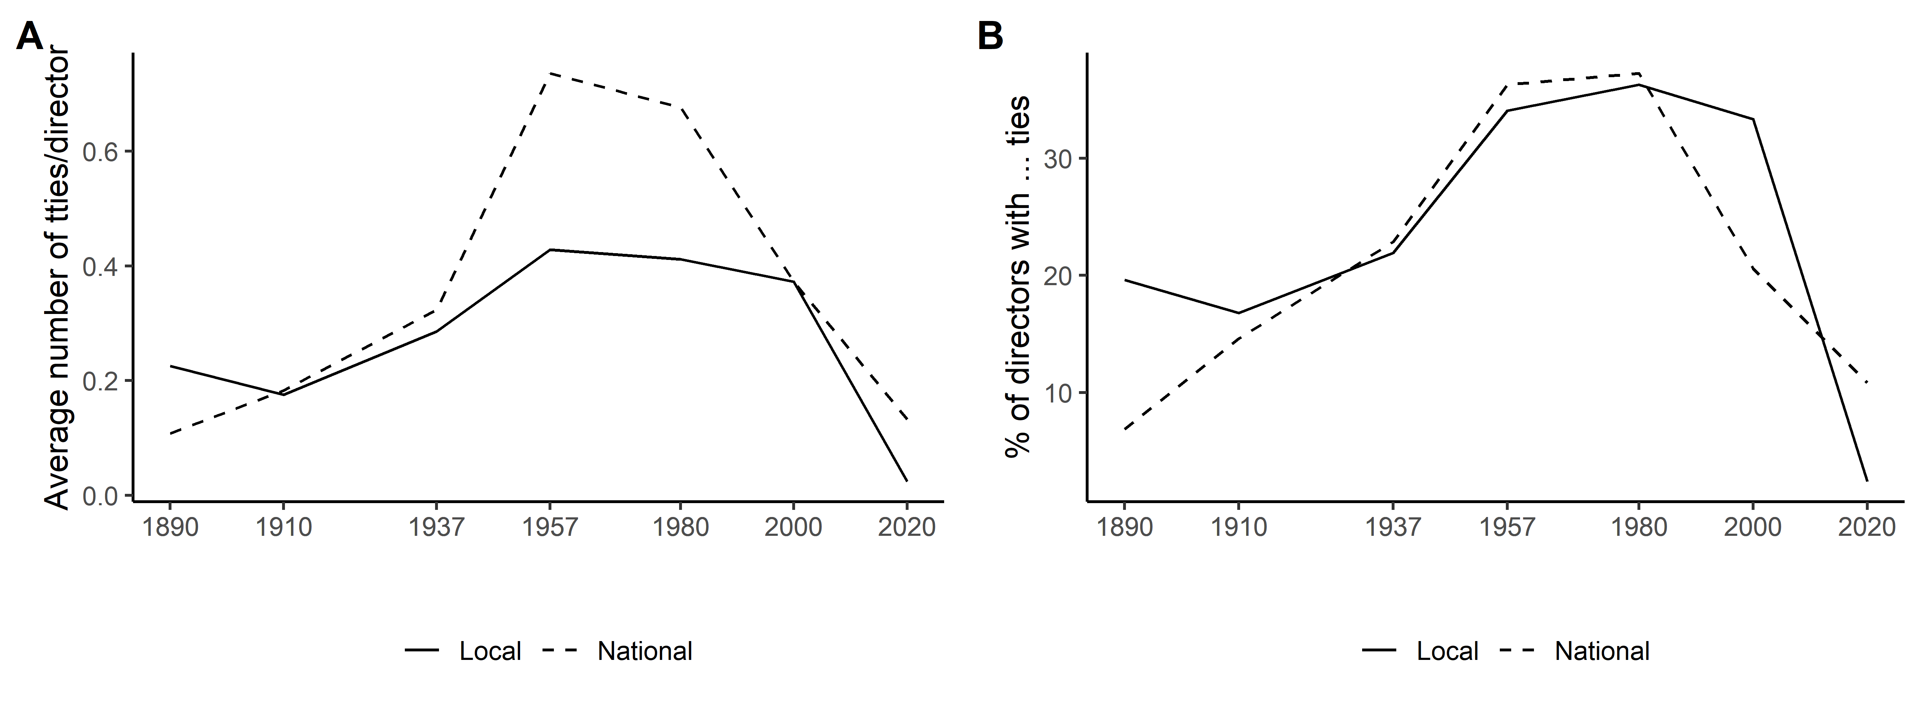
Local/national company
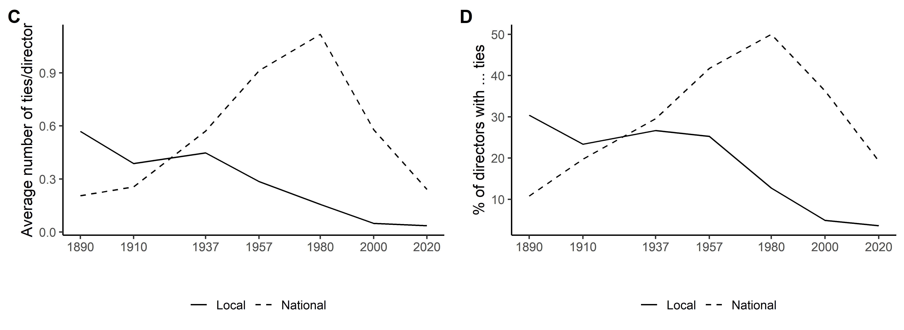
Local/national institution and/or company
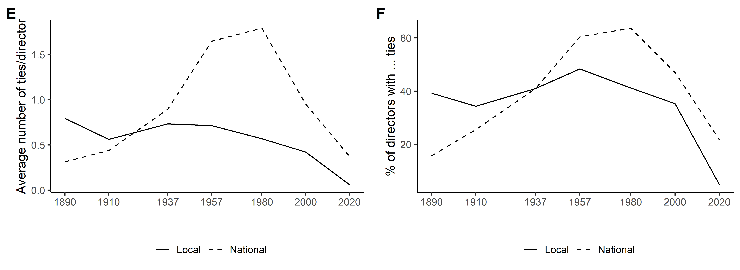

Figure A.2 Local and national ties of directors (Geneva)
Local/national institution
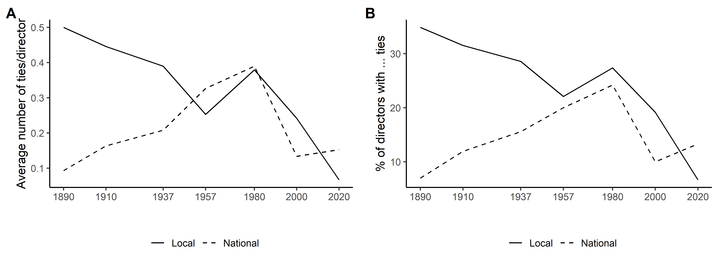
Local/national company
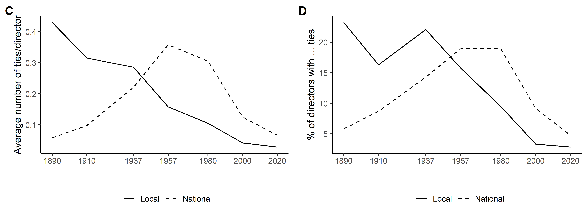
Local/national institution and/or company
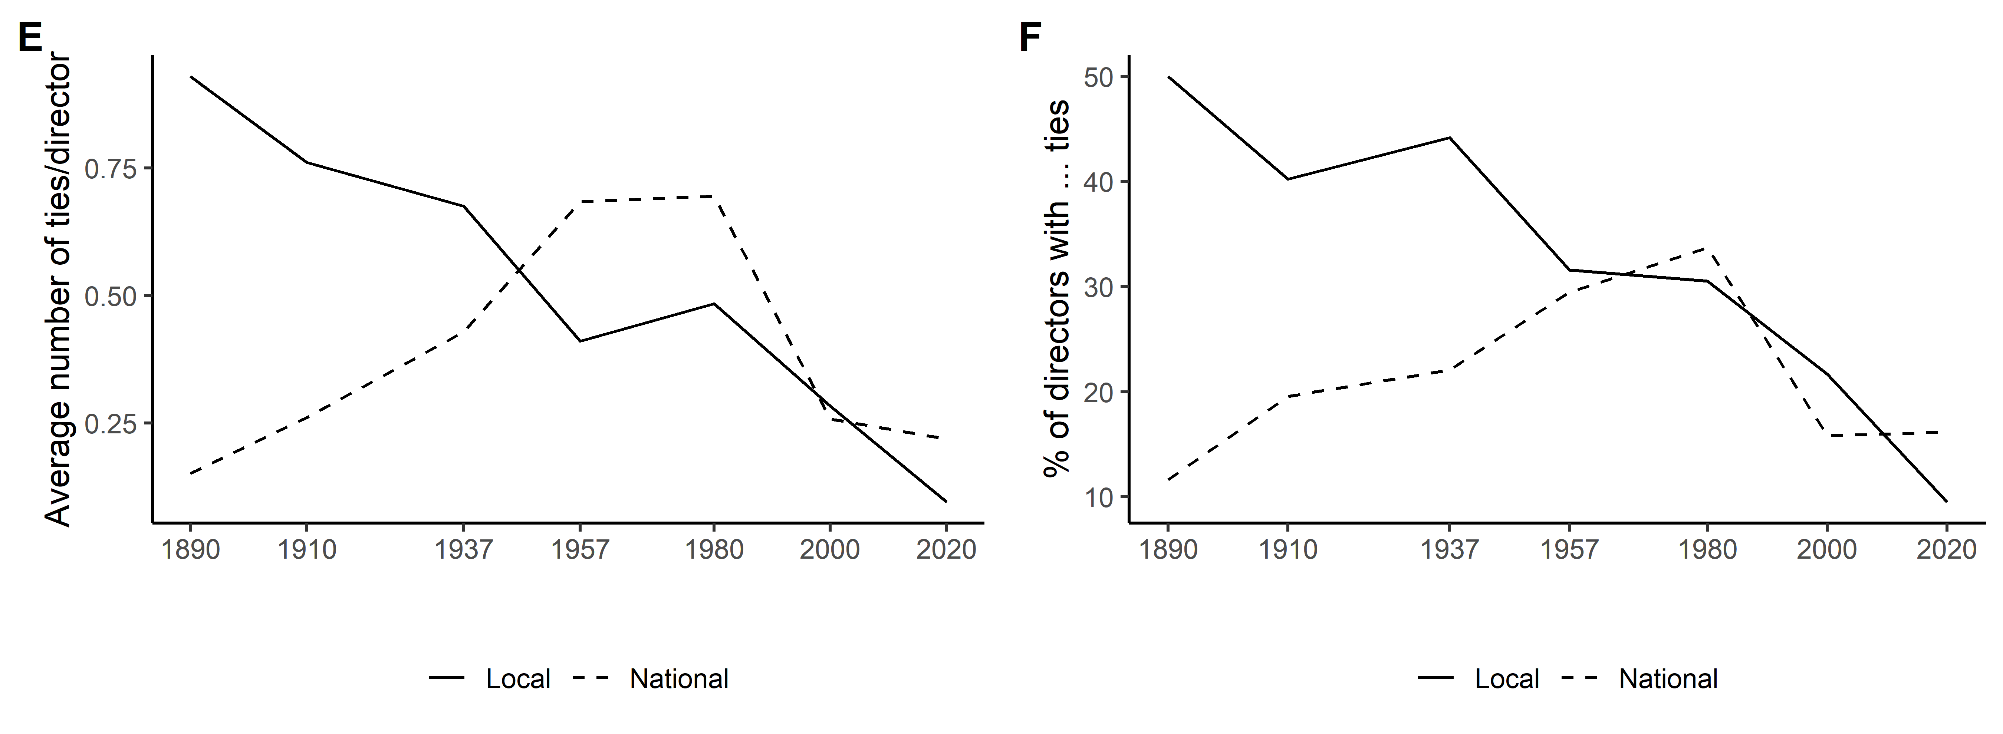

Figure A.3 Local and national ties of directors (Zurich)
Local/national institution
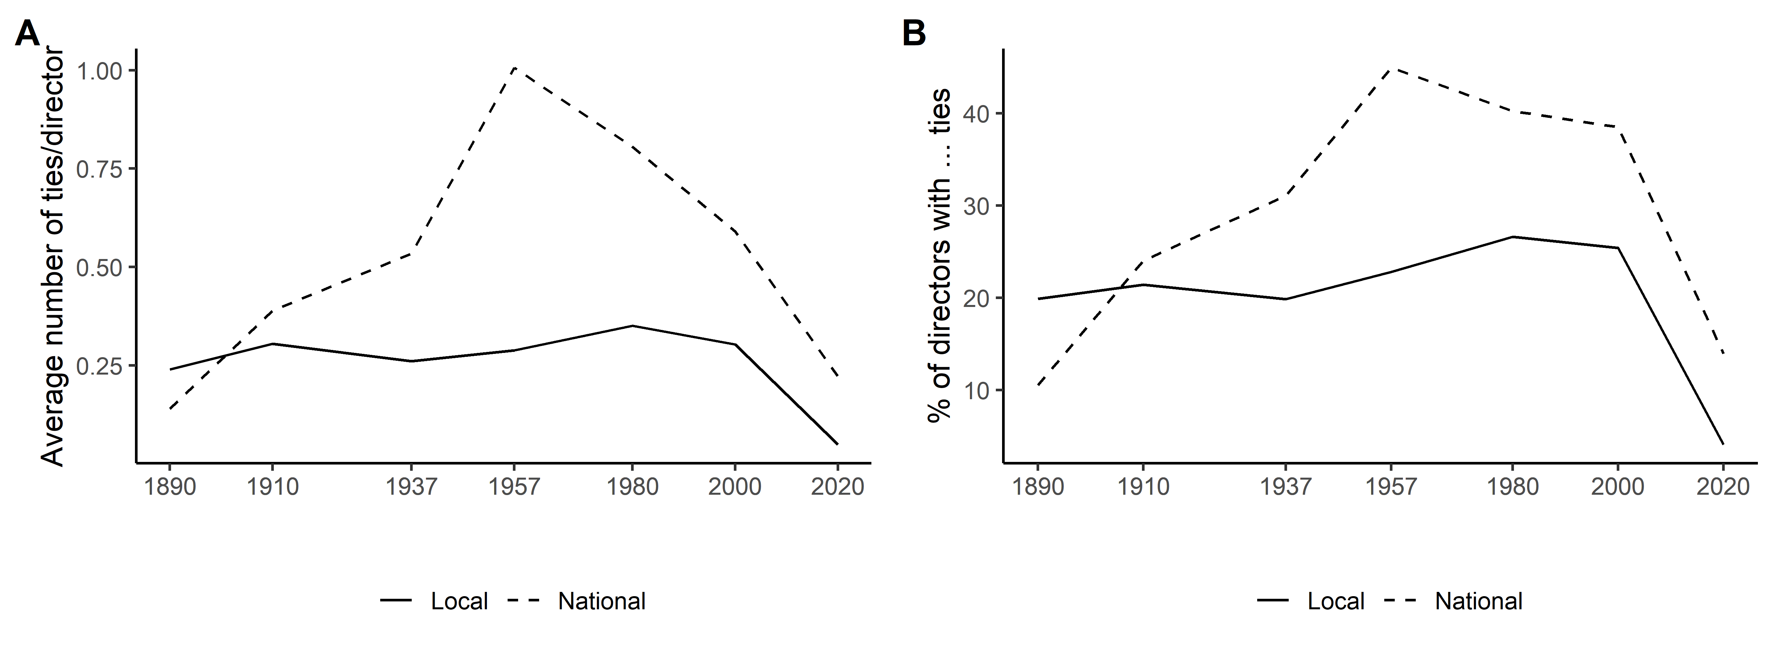
Local/national company
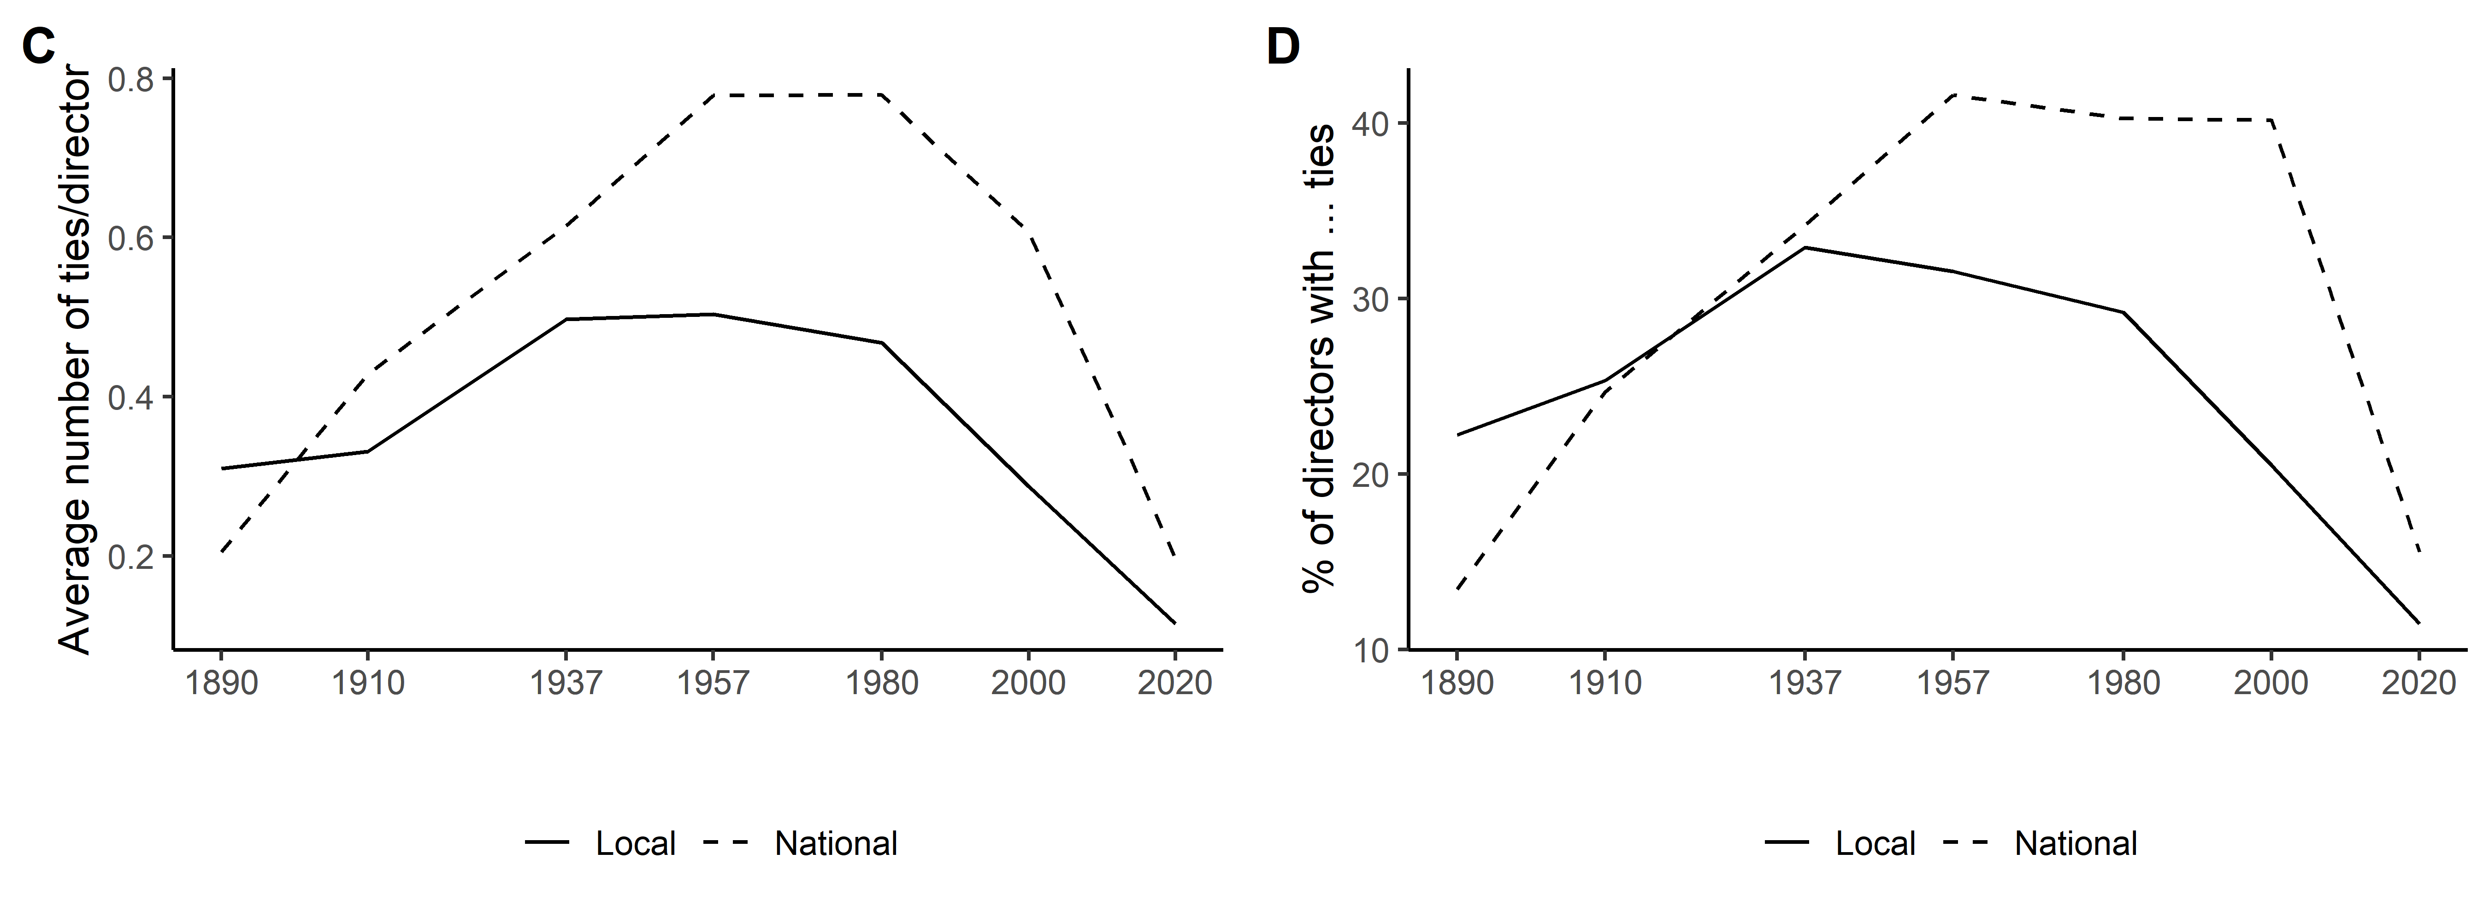
Local/national institution and/or company
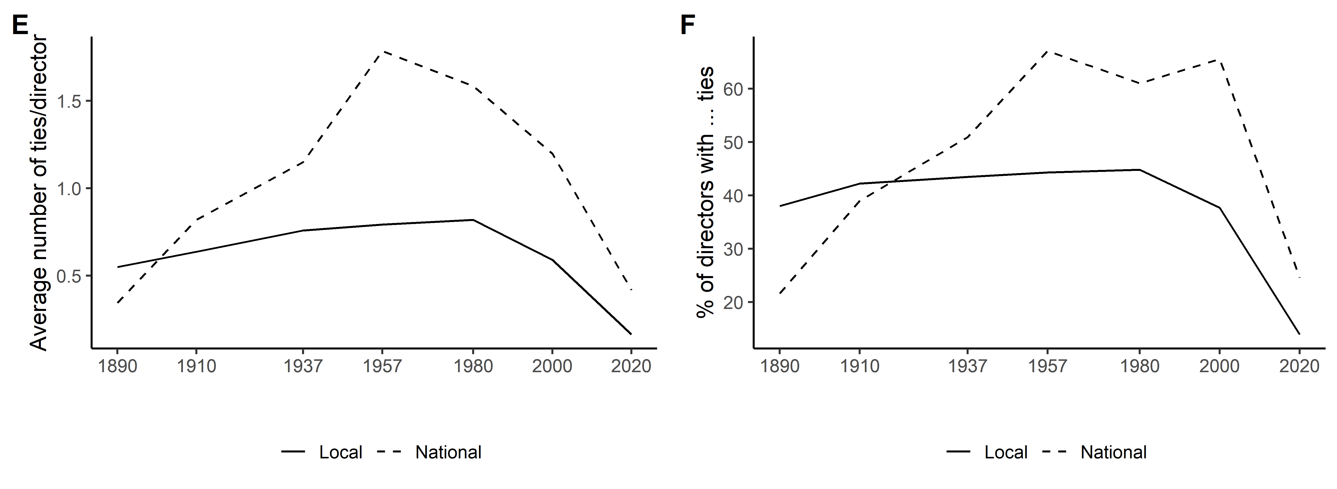

Figure A.4 Company networks (one-mode projections of bipartite networks), 1890-2020
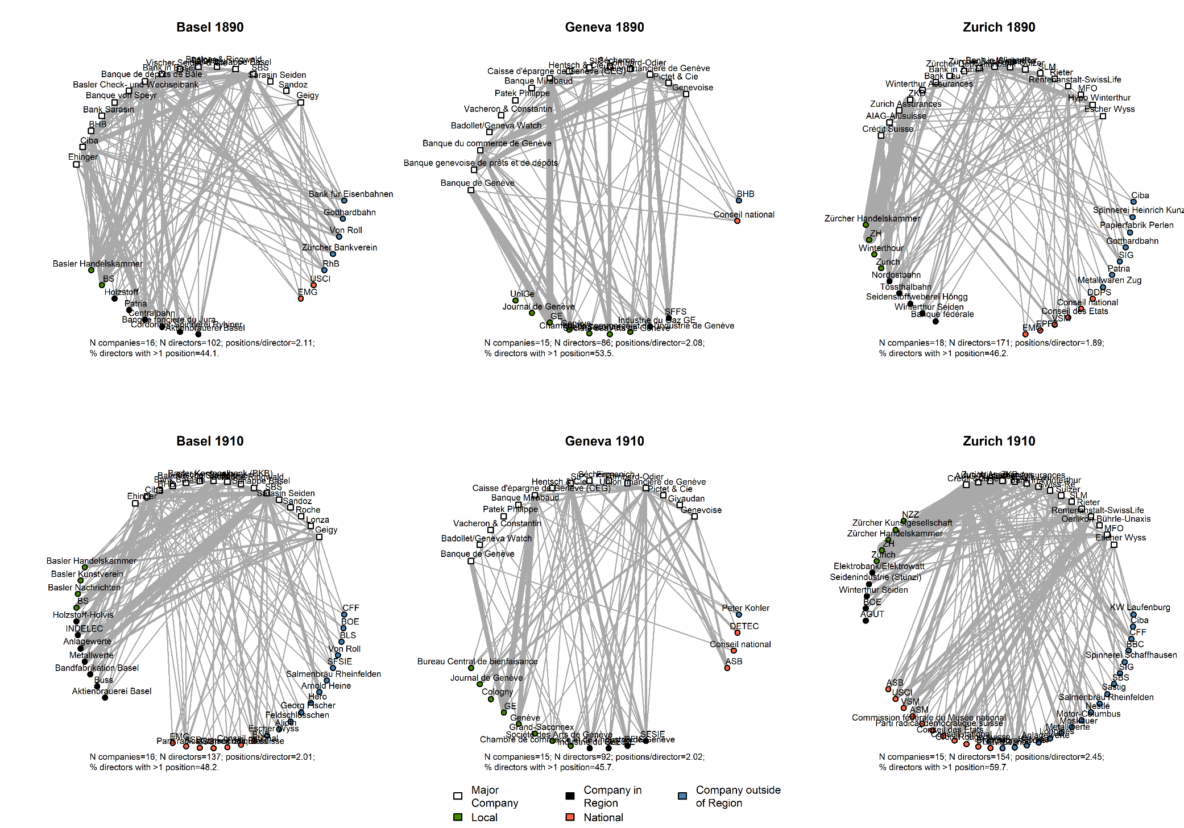
Figure A.4 Continued
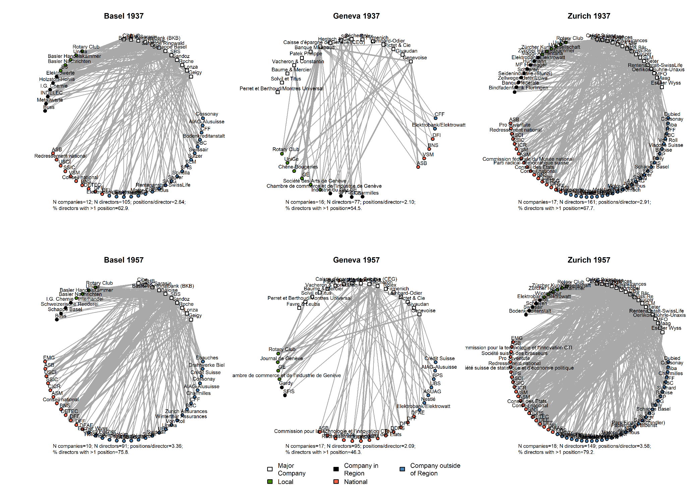

Figure A.4 Continued
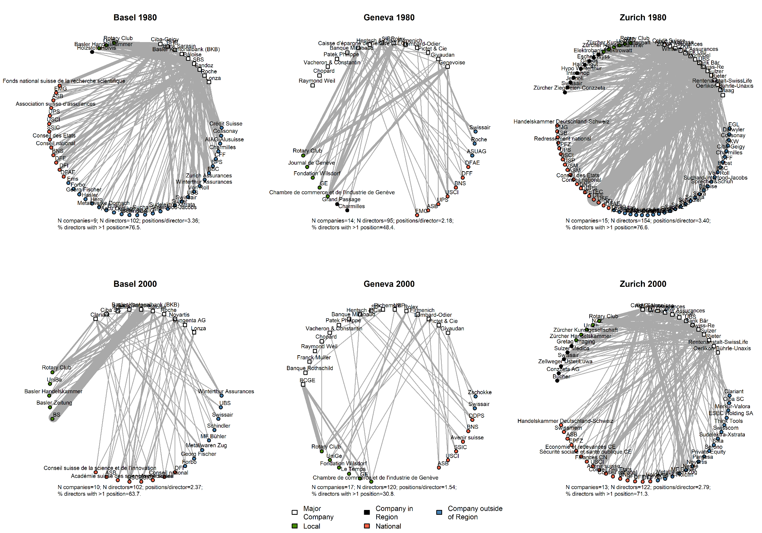

Figure A.4 Continued
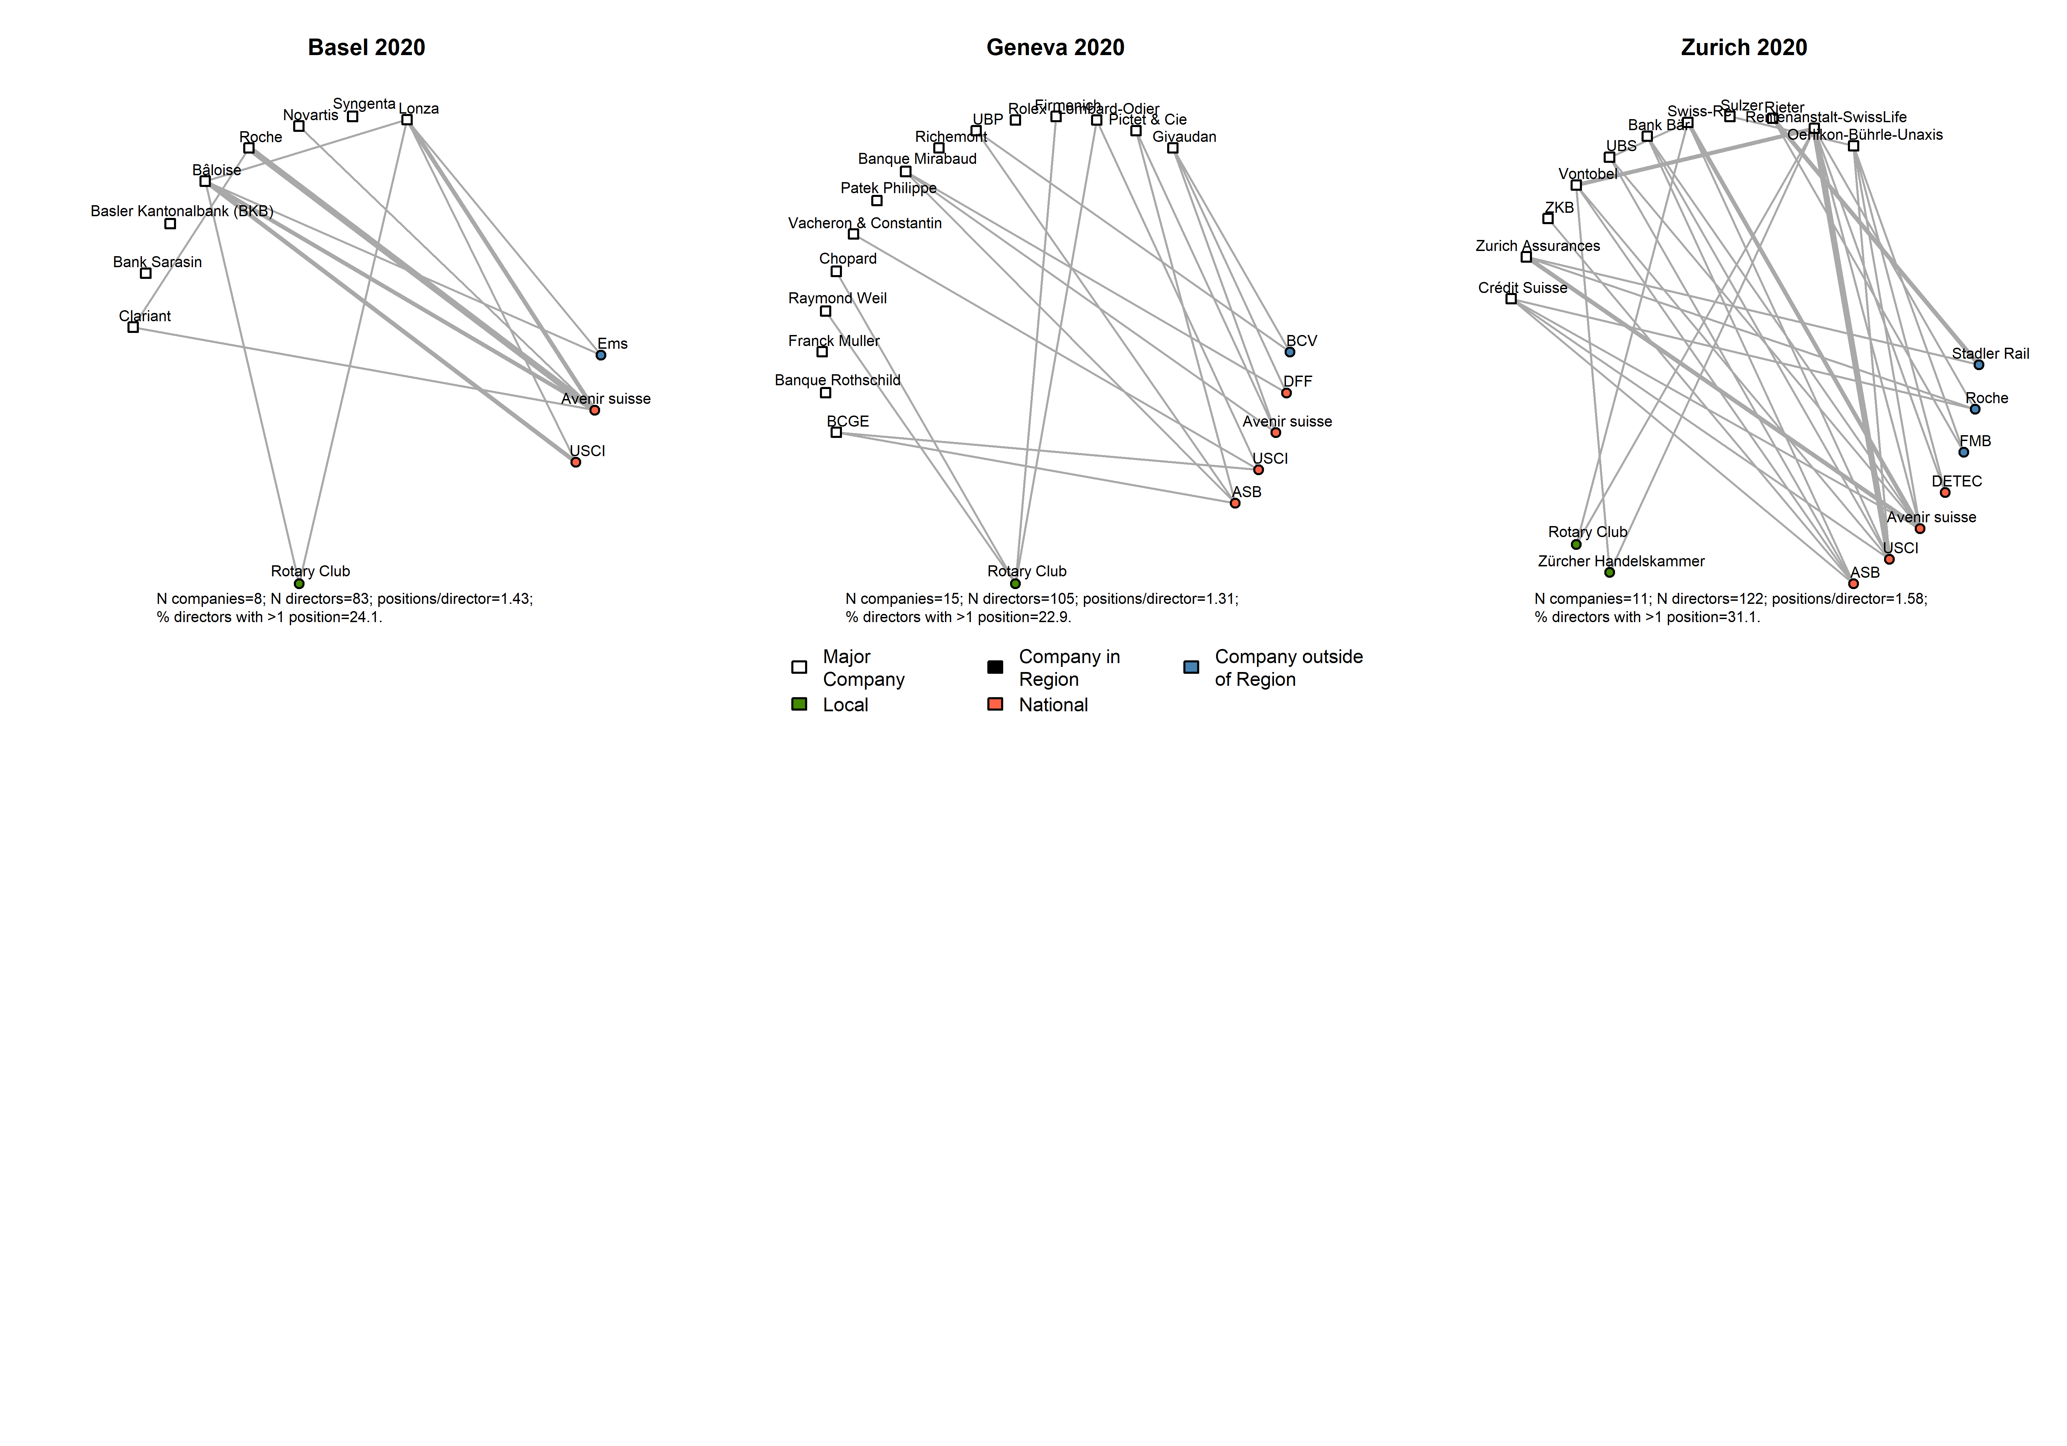

Figure A.5 Local and national ties of directors (only companies with long-term presence in sample)
Local/national institution
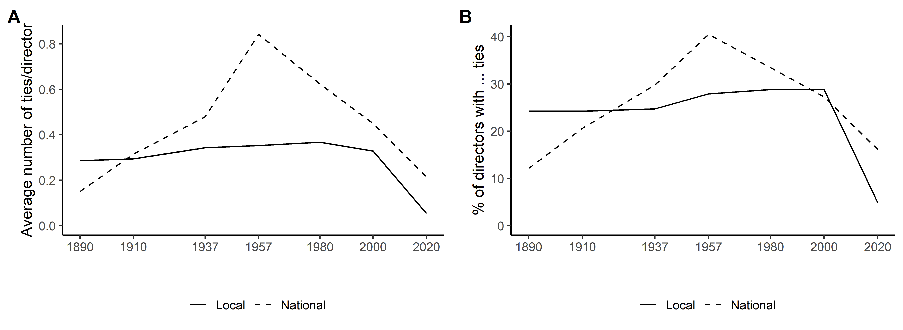
Local/national company
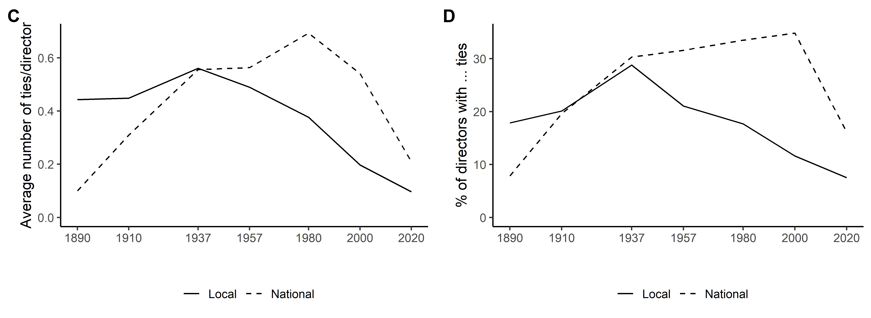
Local/national institution and/or company
